Copper Berillium Jumpers for the Barrel Modules

Building and QA

- Kapton Tape - Starting with Jumper stock from Laird, add 2 cm width kapton tape on inside of longer metal fold along the whole eight inch length ensuring that the tape goes from the bend to the edge along the length.
- Bend Protection – Place 6 strips of 1” X 8.5” paper (.027”) along the length on the inside of the jumper stock.
- Cut Strips - Cut jumper into strips .56” wide using a paper cutter. Leave cut paper inside fold.
- Indicate Slot Location - Mark bend side of the jumper strip with scribe to indicate final location of bent metal using plastic jig with tab referenced to one edge.
- Cut Fold Bevels - Using scissors cut long bevel from side to jumper fold where tab mark is on both sides. Remove paper from fold.
- Cut Paddle Ends - Cut longer jumper strip end (side with kapton) to make rounded shovel shape for RF finger sides. Then cut corners off shorter strip leaving a flat on inside is OK since a spatula will be used to push it in.
- Inspect cuts - Inspect and cut/break off any sharp edges or splinters on cut edges. We have a rotary tool nearby that allows us to grind down suspect corners/breaks etc.
- Edge Sanding - Using 240 or 320 grit sand paper sand cut edges. One at a time, push the shorter paddle laterally slightly off to each side with respect to larger paddle and slide corners across sand paper to eliminate sharp point.
- Inner Surface Sanding - Place jumper over two back to back sheets of sand paper and slide applying slight pressure to Cu Be pads to sand sharp edges inside fold.
- Slot Width Check - Check width of material at bend using calipers:
  - Thin slots: Must be < .155”
  - Wide slots Must be < .32”
A very close fit is OK.

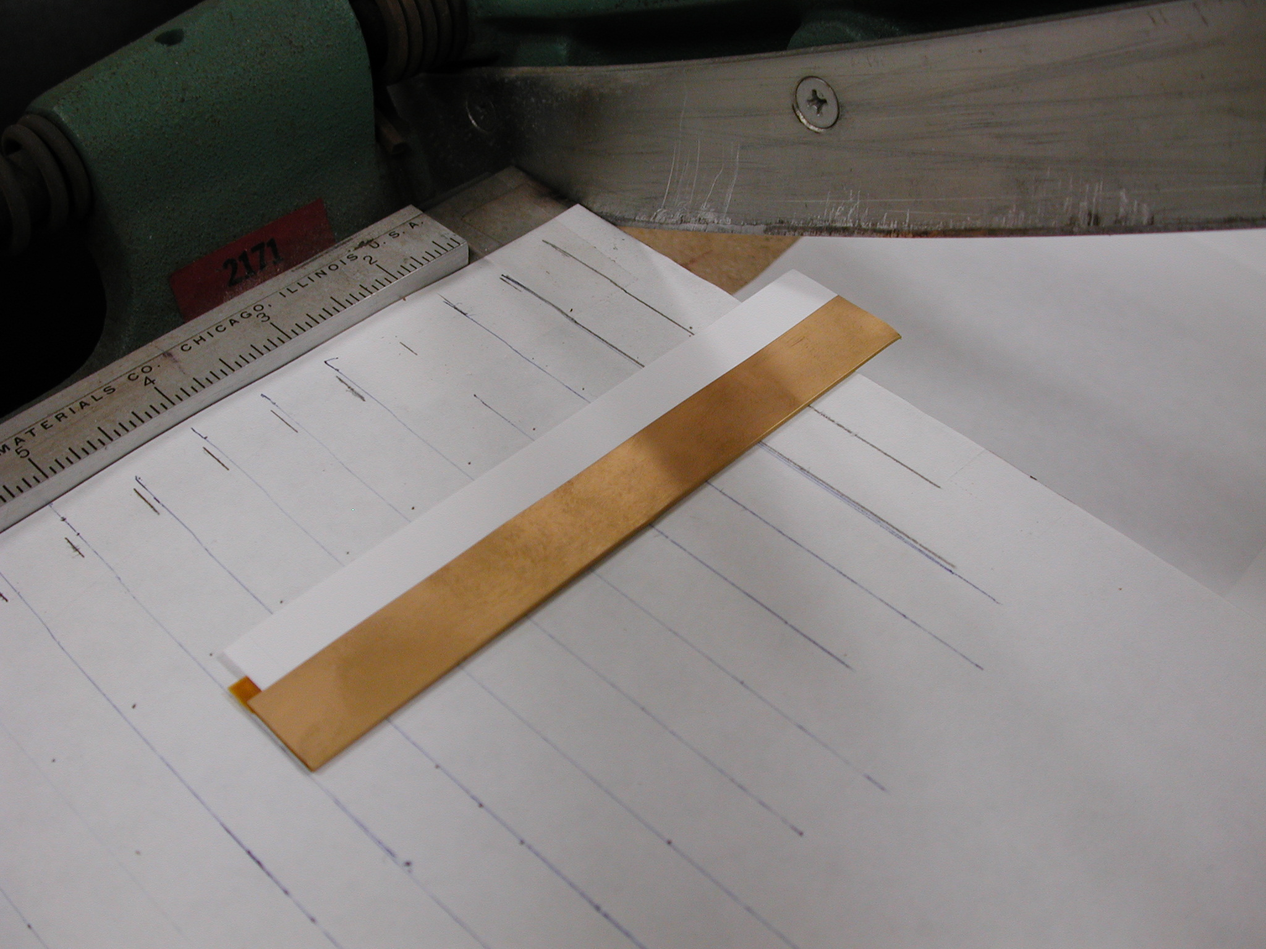
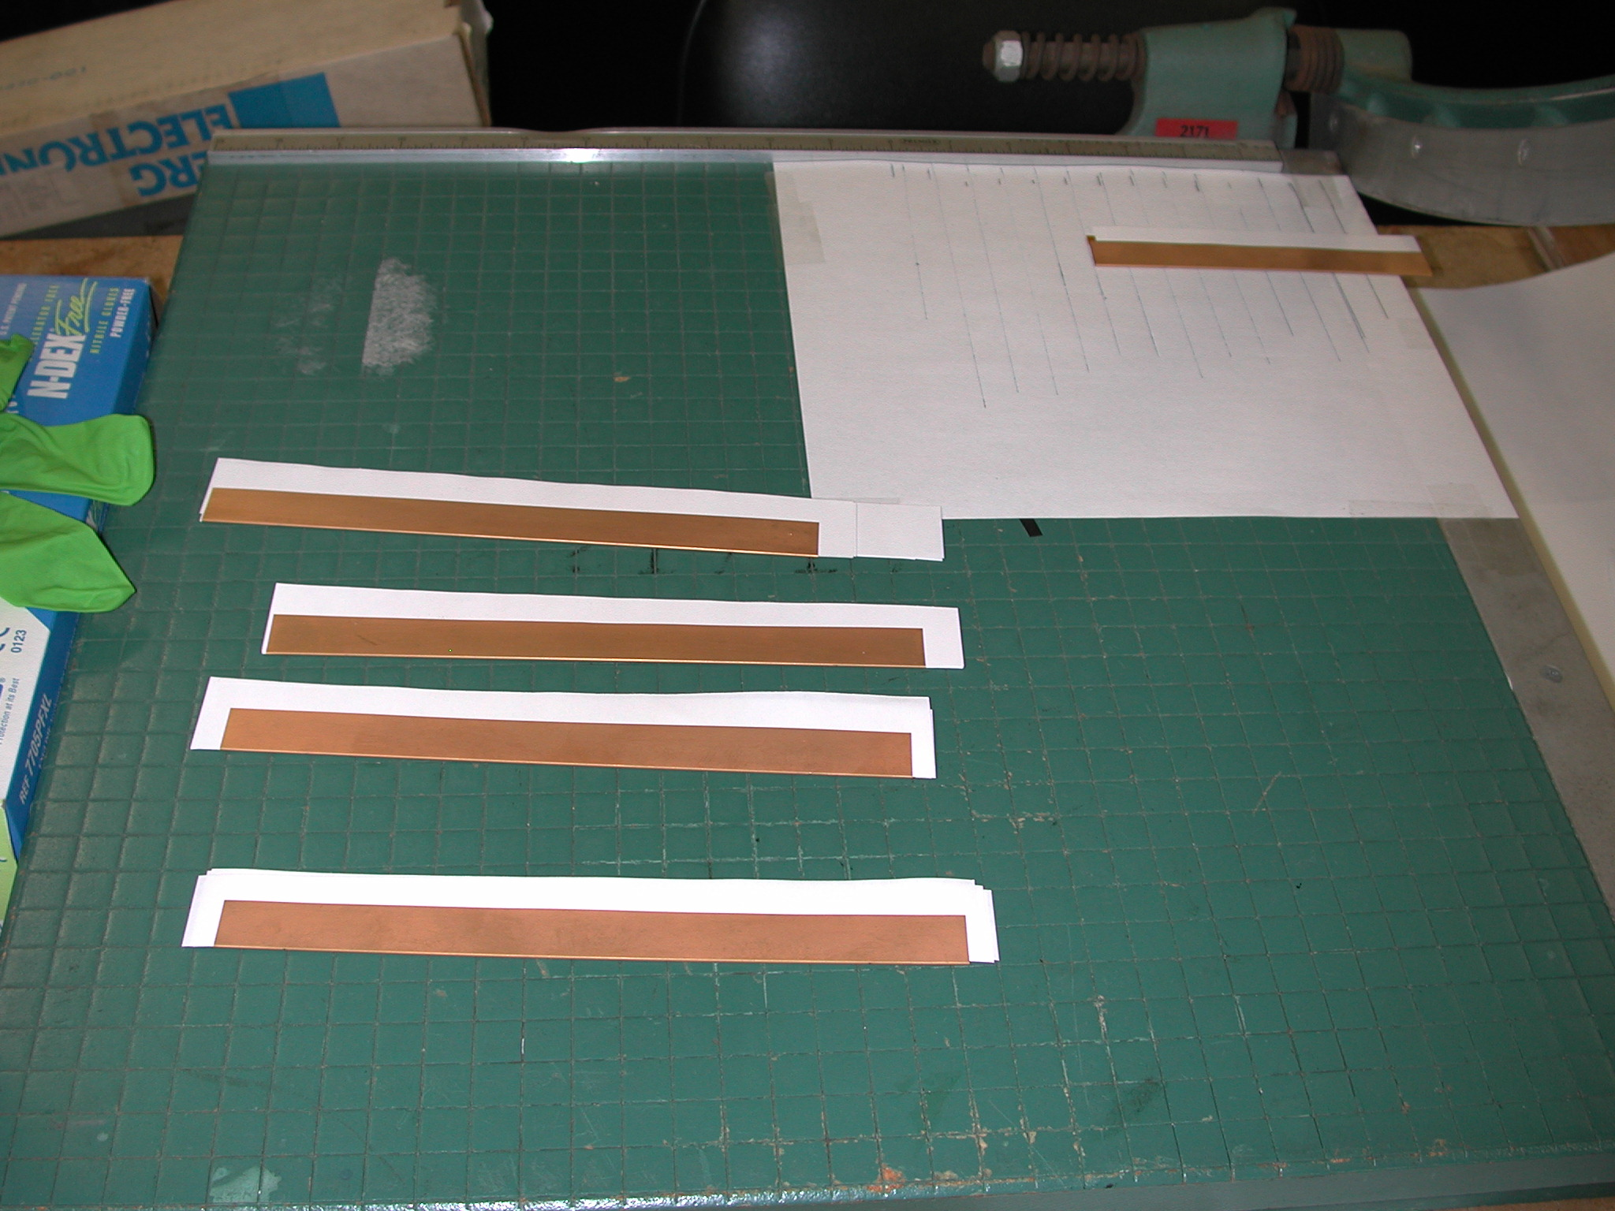
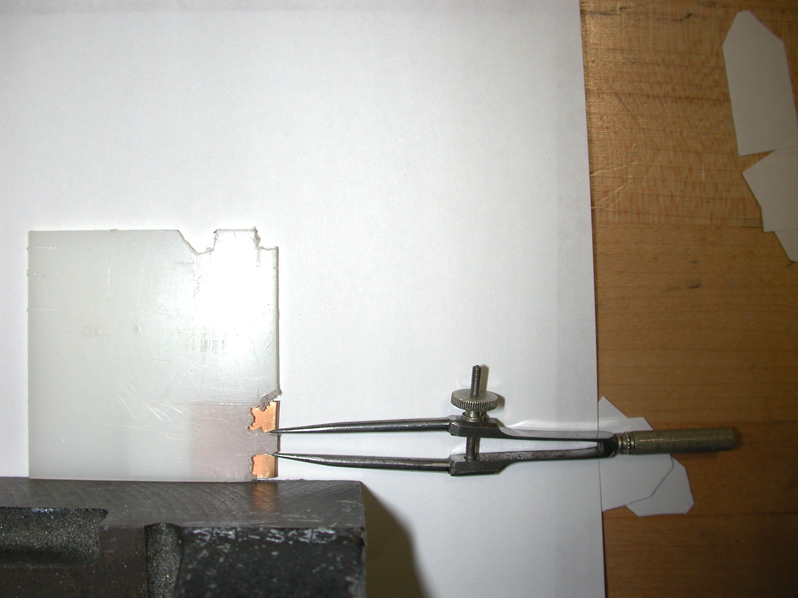
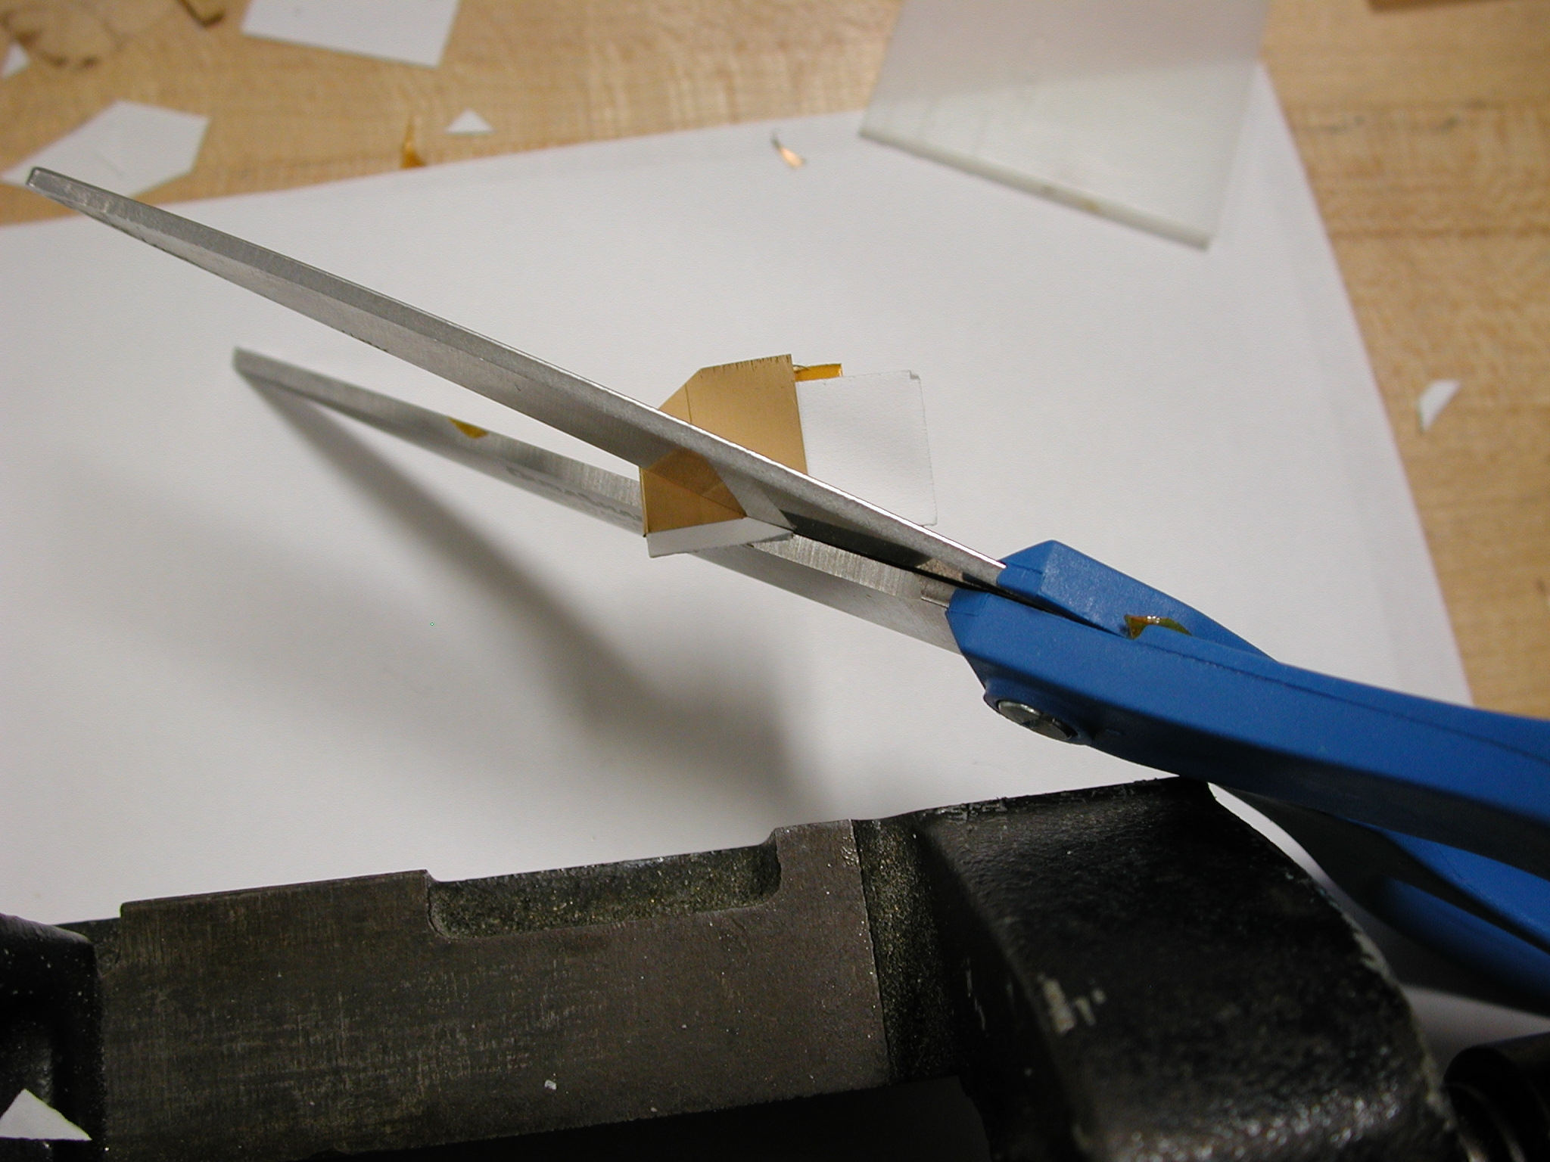
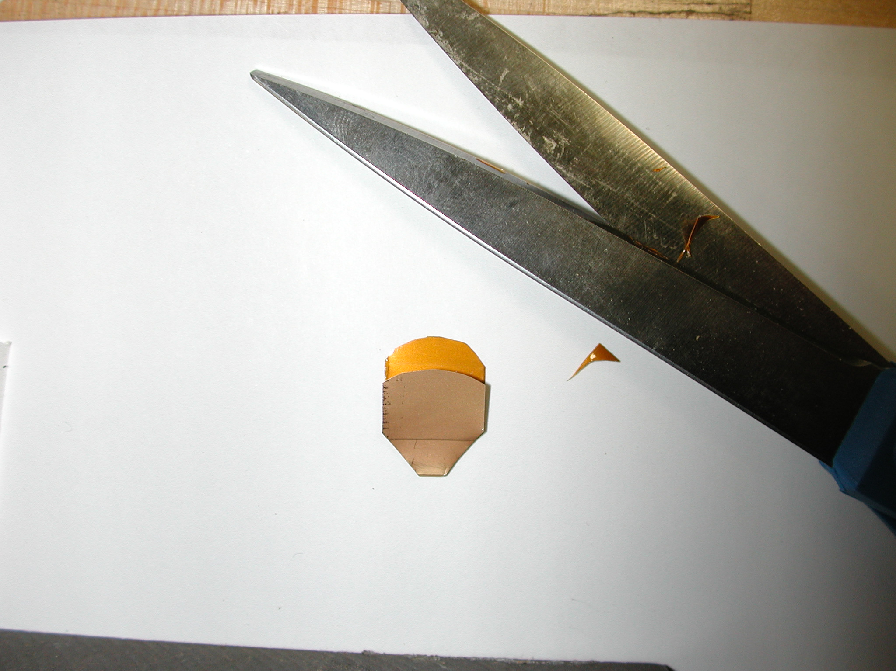
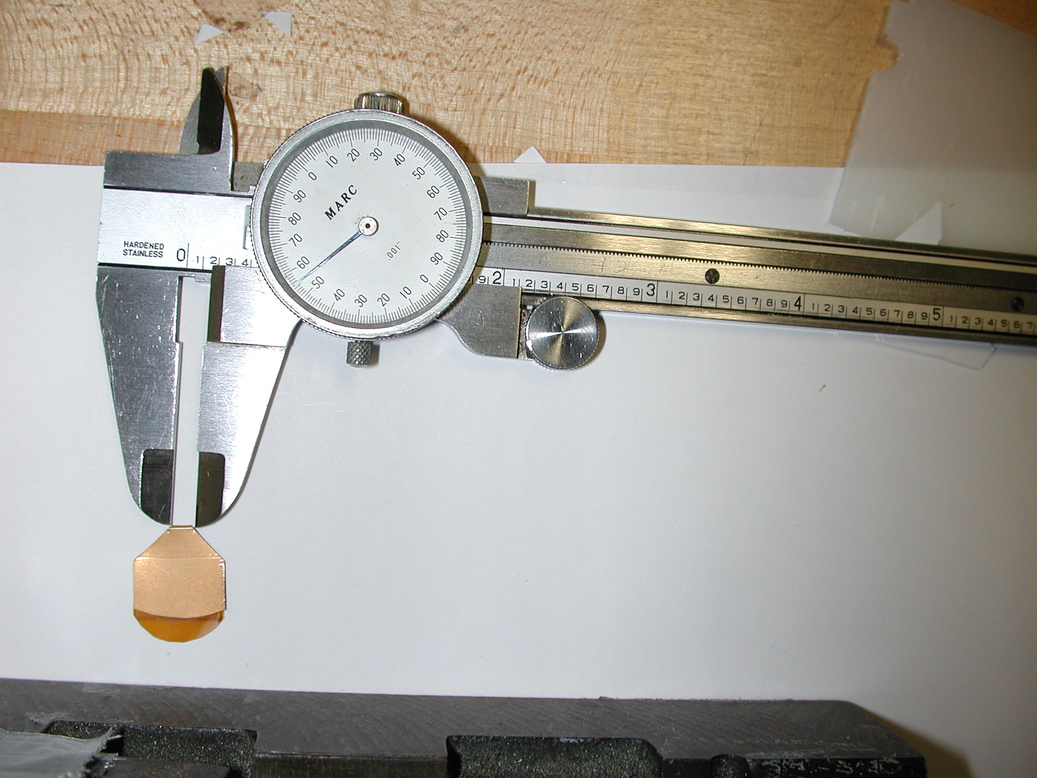
2
3

4
5
6
10

