Tests and Minor Repair of the End Cap Wheel ASDBLR and DTMROC boards
Mitch Newcomer and Ole Rohne

Since most actual circuitry is on the DTMROC and ASDBLR ASICS and they are previously tested, a significant number of remaining errors can be identified by using resistance, connectivity and diode tests between the supplies and GND. While not much can be done to re- align or resolder the ASICS, a fair number of problems may be stuffing errors or connection errors on the input or output connectors.

A and B wheel boards

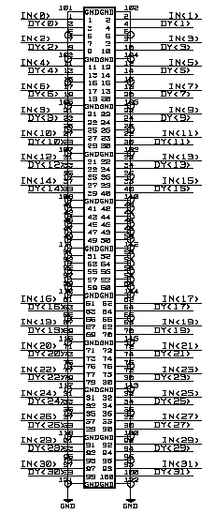
Fujitsu Connector - The Fujitsu connector goes to the ASDBLR Inputs -
Figure 1 The Fujitsu connector pinout taken from the B – Wheel schematic. Note that it is topologically correct in the relative placement of signals and that both Fujitsu connectors have functionally identical signals in identical positions.
G A B G . . .
Resistance to gnd of A or B input should be 20 – 30KΩ. Lower values may indicate a short between inputs or to gnd.

Each ASDBLR input (A,B) internally has an input protection diode to gnd wired in parallel with a 26K ohm resistor . Inputs are wired G A B G A B. on the Fujitsu connector. Likely connection failure modes due to assembly are either opens or shorts to an adjacent pin. The Appendix shows symptoms of input shorts between pins and to GND for threshold ramps.
In general a short to ground will appear as low gain channel and shorts between inputs will increase the input noise resulting in a much higher fall off than expected for the threshold ramp.

Measuring inputs with Power On.
With the power on each input should be at ~750mV. Unfortunately, it is nearly impossible to see a short between inputs since the currents through the inputs transistors are identical with or without a short, so the best you can do is determine if there is a short to gnd.

Probing inputs with power off
Probably the best probing technique is to try to make contact with the Fujitsu contact without shorting to an adjacent gnd and without pressing down on the board to falsely indicate a contact of a poorly or non soldered joint. Since DVM probes usually have features that are larger than the space between pins it’s a good idea to try to look for 28k ohms to gnd on one of the two inputs. This tells you that they are not shorted together. Then simply move the probe over to intentionally short between them and look for 14k ohms to gnd, this tells you that neither input is shorted to gnd. You can also look individually for 20 to 30KΩ on each input. We have looked for correlations between offsets and input resistance, but find no compelling relationship.

NAIS (Ternary Signal/Control) Connectors - The mating NAIS connectors carry control signals and ternary logic signals between ASDBLR and the DTMROC. There are only a few grounds nearby. The usual failure modes are either opens or shorts between pins. Figure 2 is a topogically correct connector schematic taken from the first 16 channels of a B wheel board. Signal functionality by pin position among all ASDBLR NAIS connectors is the same for A, B and DTMROC boards.
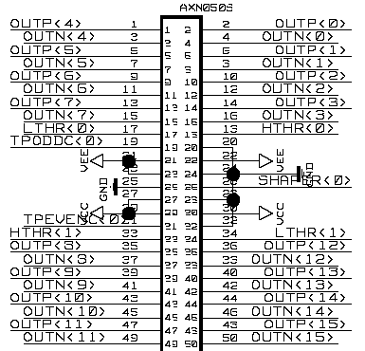
Figure 2 Topological layout of the End Cap Wheel NAIS connector taken from the B wheel schematic. All NAIS connectors have signals with identical functionality at matching positions.

Finding or testing for assembly connection errors- The protection diode on the ASIC can be forced to conduct using the diode test function on the DVM. If VEE and GND are shorted
intentionally, for instance using a conductive clip across one of the Vee-GND filter capacitors
then the diode test can be used between gnd and any signal with an input protection diode.
(Reverse leads and check again if there is an apparent open.)
This will test for shorts to the supply and opens but not shorts between pins. Unfortunately there is not an easy way except by direct testing between pins to assure there is no short between pins.
We have listed the expected resistance and “diode test” values on the NAIS connectors for both
ASDBLR ( Table 1 ) and DTMROC (Table 2) boards.

Table 1 Measured Resistance and Diode voltage to GND for the ASDBLR NAIS connectors.
ASD-BLR NAIS Connector
Odd Pins |  |  |  | Even Pins
Pin # | Impedance | Diode Voltage (V) |  | Pin # | Impedence | Diode Voltage(V)
1 | 8.73M | 0.823 |  | 2 | 8.7M | .822V
3 | " | " |  | 4 | " | "
5 | " | " |  | 6 | " | "
7 | " | " |  | 8 | " | "
9 | " | " |  | 10 | " | "
11 | " | " |  | 12 | " | "
13 | " | " |  | 14 | " | "
15 | " | " |  | 16 | " | "
17 | " | 1.243 |  | 18 | " | 1.24
19 | Overload |  |  | 20 | 0 | 0
21 | 82.2K | 1.2 |  | 22 | 85K | 1.2
23 | 82.2K | 1.2 |  | 24 | 0 | 0
25 | 0 | 0 |  | 26 | 12.2K | 1.8
27 | 1.46K | 0.585 |  | 28 | 0 | 0
29 | 1.46K | 0.585 |  | 30 | 1.46K | 0.585
31 | Overload |  |  | 32 | 0 | 0
33 | 8.3M | 1.2 |  | 34 | 8.3M | 1.2
35 | 8.73M | 0.82 |  | 36 | 8.7M | 0.82
37 | " | " |  | 38 | " | "
39 | " | " |  | 40 | " | "
41 | " | " |  | 42 | " | "
43 | " | " |  | 44 | " | "
45 | " | " |  | 46 | " | "
47 | " | " |  | 48 | " | "
49 | " | " |  | 50 | " | "

Table 2 Measured resistance and Diode test voltage to GND on DTMROC NAIS connector.
DTM-ROC NAIS Connector
Even Pins |  |  |  | Odd Pins
Pin # | Impedence | Diode Voltage(V) |  | Pin # | Impedence | Diode Voltage (V)
2 | 7.6M | 0.73 |  | 1 | 7.6M | 0.73
4 | " | " |  | 3 | " | "
6 | " | " |  | 5 | " | "
8 | " | " |  | 7 | " | "
10 | " | " |  | 9 | " | "
12 | " | " |  | 11 | " | "
14 | " | " |  | 13 | " | "
16 | " | " |  | 15 | " | "
18 | 5.2K | 0.45 |  | 17 | 5.26K | 0.448
20 | 0 | 0 |  | 19 | 7.05K | 0.608
22 | 1.03K | 0.468 |  | 21 | 1.03K | 0.47
24 | 0 | 0 |  | 23 | 1.03K | 0.47
26 | 1.584M | 0.539 |  | 25 | 0 | 0
28 | 0 | 0 |  | 27 | .603K | 0.293
30 | .6K | 0.292 |  | 29 | .603K | 0.293
32 | 0 | 0 |  | 31 | 7.03K | 0.603
34 | 5.25K | 0.447 |  | 33 | 5.26K | 0.447
36 | 7.6M | 0.73 |  | 35 | 7.6K | 0.73
38 | " | " |  | 37 | " | "
40 | " | " |  | 39 | " | "
42 | " | " |  | 41 | " | "
44 | " | " |  | 43 | " | "
46 | " | " |  | 45 | " | "
48 | " | " |  | 47 | " | "
50 | " | " |  | 49 | " | "

Shorts between Ternary and Adjacent lines show up as a lower forward biased voltage when performing diode checks.

Stuffing errors - A visual inspection of the boards should be sufficient to identify missing components but a meter can be helpful as a sanity check to test resistors. Although usually near the stuffed value, resistors measured “in” circuit are not accurate. One simple thing to do is to compare resistance measurements with a “standard” or other boards known to work well.
Stuffing diagrams and schematics can be found on the Penn website
http://www.hep.upenn.edu/atlas → on detector boards

or on EDMS

Threshold offsets - If all channels attached to one DTMROC have a lower threshold sensitivity it may be an un-stuffed or possibly mis-stuffed component. Its reasonably easy to
test for this by locating the threshold capacitors on the bottom of the ASDBLR board with the DTMROC board attached. After power up (reset) the threshold voltage will be 1.2V to 1.3V so the test pulse capacitors can easily be identified by looking for this voltage under the DTMROC
chip in question. There are four thresholds per DTMROC.
The DAC output voltage can be tested under power and compared to a working board or it may be tested for resistance of ~ 6K to gnd. If the value is much smaller, the capacitor may be mis-stuffed with a resistor or one of the ASICS is likely bad. If the value is much larger, the series 1K resistor may be a much larger value.

Ternary Outputs always ‘ON’ - Several problems may cause one or all channels on an ASDBLR to report an output always triggered independent of threshold:
- An open input with one or more of the 4 ball connections involved on each channel not connected. This would usually affect one or a few channels although it could affect all channels.
- If all channels on an ASDBLR are consistently high:
  - The Ternary current setting resistor (12KΩ) on the output side of the ASDBLR may not be stuffed or may have a bad solder connection. Check this by inspecting the output side of the ASDBLR. The resistor can be measured fairly accurately “in circuit”. Since there are no other 12KΩ resistors it should be easy to find the proper position to check on a working board. If it is stuffed check for a voltage drop across it. One side is referenced to +3V and there should be a drop of more than 2V across it. If there is not drop, the ball contact, J9, on the ASDBLR may not be connected.

  - The Threshold setting ball contacts J1 or H1 may be open. To test “in circuit” look for a current drop across the threshold setting filter resistor (12Ω) near the output side of the ASDBLR. This resistor may be found by powering up the board and looking with a DVM for 1.2V as mentioned above. To test for an open contact measured the voltage drop across it. A value of 1-2mV confirms connection to the ASDBLR, but a high beta in the input transistors on the ASDBLR may make this hard to measure, so the most convincing way to prove that contact is not being made is to remove the threshold setting resistor and test diode drop (.7V) on the ASDBLR side using the DVM diode tester. This confirms the on chip input protection diodes are attached.

Connector contact repair –
Shorts
Two tricks that have had some success in removing shorts between pins:

- Solder wick is helpful when the short can be seen.
- If the short is not visible, apply a small amt of liquid flux between pins
and then use solder wick over the pins. If this doesn’t work, sometimes adding a small amt of solder between pins will help get the heat and flux where it needs to be.

Opens ( contact not made) - Quite often “opens” are intermittent. Use a pick or other sharp tool to push on the contact in question. If it is not soldered it will move and needs repair. Just adding solder usually works, but if the residual amount solder is very small, adding flux may help.

Appendix I - The following comments are specific to the end cap wheel test setup and have been provided by Ole Rohne .

The figure below can be used to relate the physical address of each DTMROC ASIC when attached to the End Cap Wheel Tester.

#1
#0
#3
#4
BUC
#5
#4
#6
#7
#9
#8
#10
#11
Figure 3 The physical orientation of the End Cap Wheel Tester. Numbered Boxes indicate the address of each DTMROC.
Locating Problematic Channels - The test program starts with ‘0’ and follows the address ordering of the DTMROC board. The DTMROC address is indicated with copper etch number, not silk screen, located near each DTMROC ASIC. If the program indicates Channel #132 is failing, locate the DTMROC and channel within the DTMROC as follows:
Divide the channel number by 16 to locate the proper DTMROC chip, the remainder gives a DTMROC channel number. Ex: Program channel 132 = 16 * 8 + 4
Indicates DTMROC = 8 channel = 4

The production tester displays 50% points with and without the test pulse applied.
Table 3 Failure symptoms with the End Cap Production Tester
Characteristic Failure Symptoms in the End Cap Production Tester
Input short to ground | Low value of 50% point both pulsed and not pulsed.
Input shorts between A - B | Nearly identical values for pulsed and not pulsed 50% points.
Open Ternary Line | Constant value or “stuck bits”, ‘0’ or very high 50% thresholds.

Appendix II - Threshold occupancy ramp, derived triggering frequency and pulse response for different input connection cases.
Note that the indicated symptoms may arise due to different causes.

Case I Normal (Low) Threshold Ramp Response.

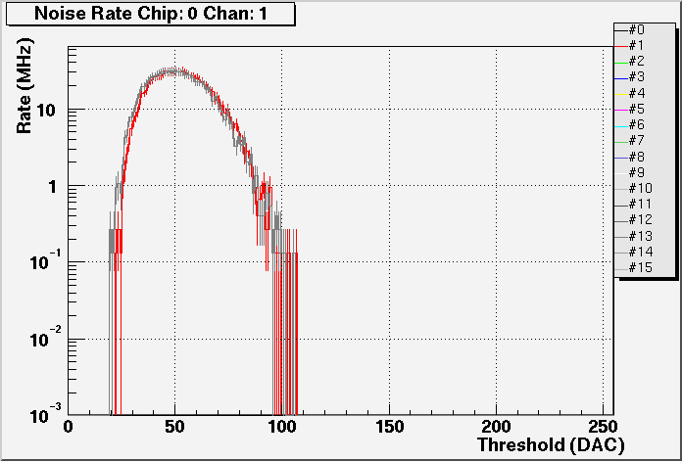
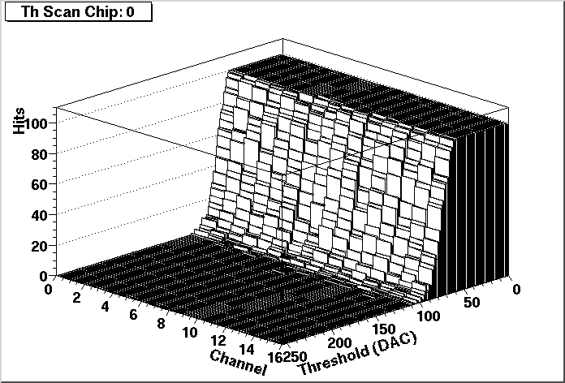
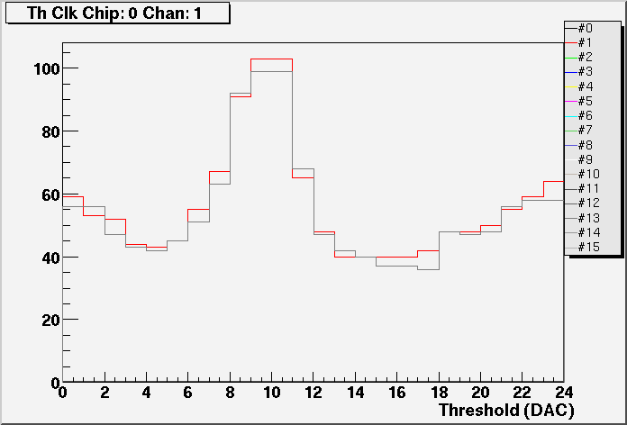

Internal Test Pulse

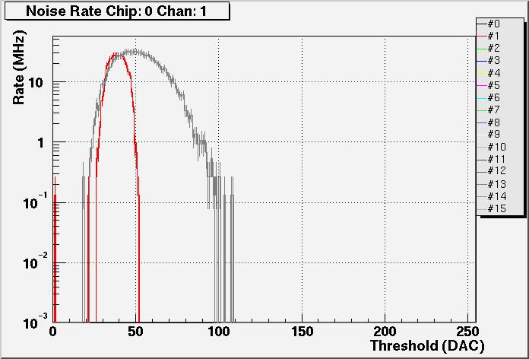
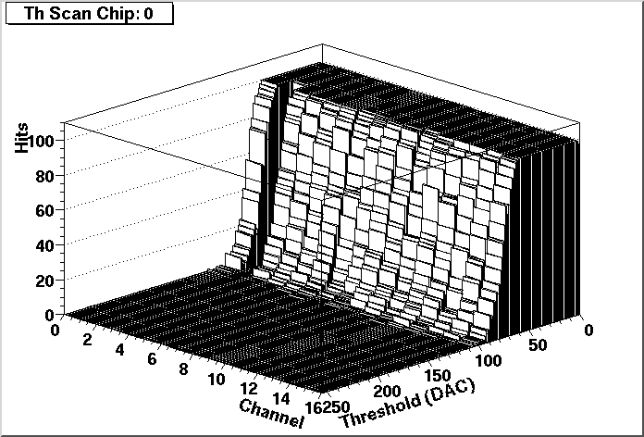
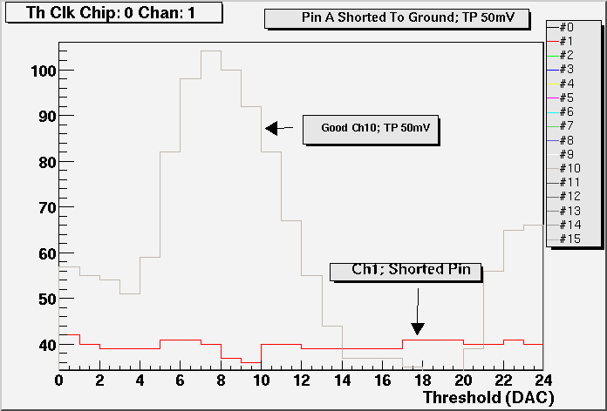
Case II One input Shorted to GND. ( ALSO internal open in signal path)
External Test Pulse

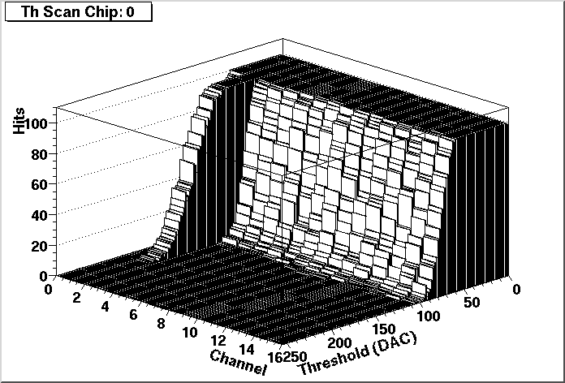
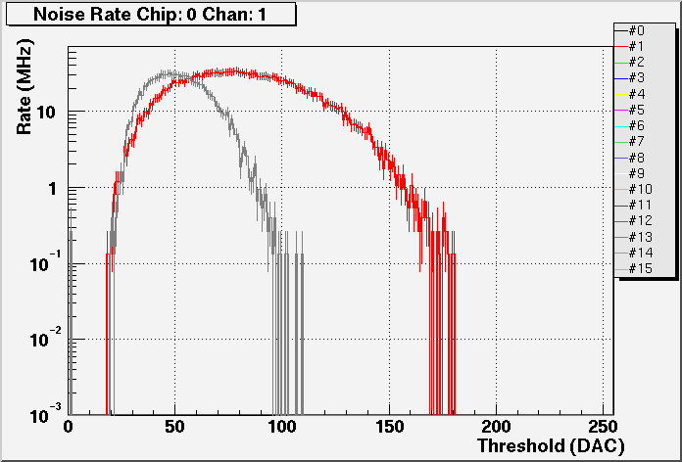
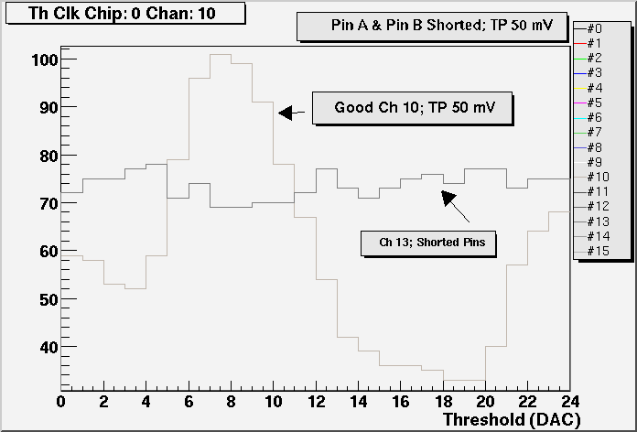
Case III A and B inputs of one channel shorted together.

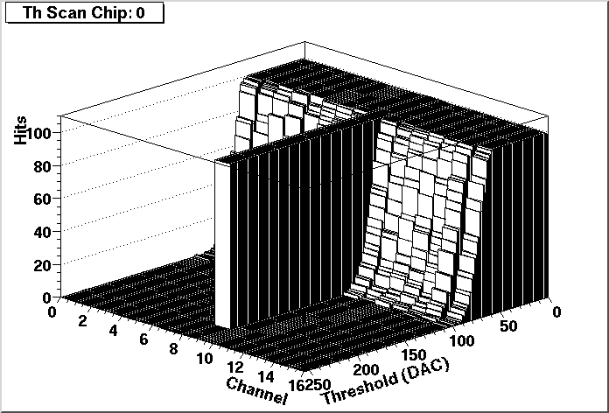

Case IV - Outputs open or disconnected between DTMROC and ASDBLR board.

Note that this is a work in progress. Edits, corrections, additions are welcome (mitch@hep.upenn.edu).
We use Kester folmula 197 liquid flux.

